Your Theory of Action Coat of Arms
Instructions & Conversation Starters

Purpose
To imagine your empowering future informed by your past, present, and inspirations.

Instructions
Complete each element of your Coat of Arms with an image, words, or photos that capture the essence of that element. Share with a friend, family member, or group.

Conversation Starters for Each Element
Family  - What title would you give your family story as depicted in this element?  - How does your family today make a richer or poorer whole?  - What are complimentary traits or characteristics today?  - What creates tension today? What has created tension in the past?  - What has your family of origin provided you? | Work  - To what extent do you find your work or profession meaningful, that is, aligned with your personal sense of purpose?  - What unique talents or strengths do you bring to your work?  - What work activities do you find most energizing? Least?  - What changes would you like to make in your work or profession? Why? What’s stopping you?
Inspirations  - Who or what have you found inspiring thus far in your life? What about these people or ideas do you find inspiring? How would you sum up their message?  - In what ways have those who have inspired you influenced your life today? What are they calling on you to do next?  - Who would you most like to learn from next? | Values & Strengths  - What three to five values matter most to you today? Why?  - How do your values show up in your work? Your family life? Your play?  - What do you find energizing or exciting about your strengths?  - In what ways might you deepen or build on your strengths?
Proud Past  - What personal accomplishments, stories, or events make you proud?  - What common themes emerge that link the experiences of your proud past together?  - What does your proud past say about the work you are drawn to? | Pleasant Present  - What’s working for you today? What makes it pleasing?  - When thinking of the pleasant present, what images come to mind?  - What actions did you take to create this?  - If you received an engraved reward, what would it be for?
Preferred Future  - Looking ahead a year, three years, five years:  - What accomplishments, events, or experiences might you point to with pride?  - what might you regret?  - What images come to mind that capture the future you hope to create?  - How does your preferred future reinforce your pleasant present? What changes are implied?  - What first steps will you take to create the future you imagine? When? | Motto  - What overarching maxim, phrase, or word best expresses a pivotal guiding principle informing all aspects of your life?  - What about your motto do you find compelling?  - In what ways is your motto demonstrated in your interactions with others? In your private pursuits?  - How might you live your motto more fully in the future?
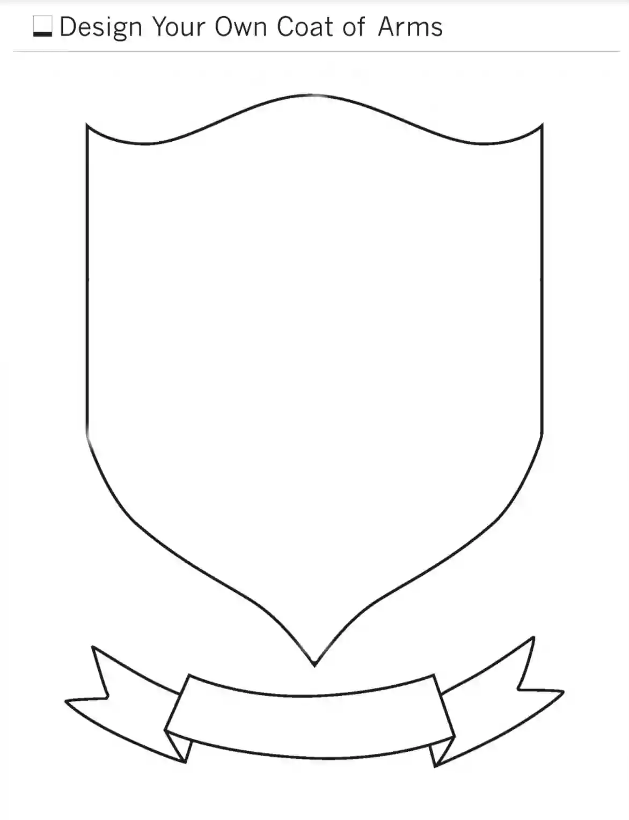
Work
Family
Pleasant Present
Proud Past
Inspirations
Values
Strengths
Preferred Future
Motto
Name

“Your Theory of Action Coat of Arms” draws inspiration from the fields of organization development, family systems, positive psychology, adult development, and appreciative inquiry.
Take the free VIA Character Strengths Survey to identify your top five strengths.

